Data and system redundancy – Data redundancy ensures an organization can provide continued operations or services in the event something happens to its data.

Back-up systems – it is a copy of computer data taken and stored elsewhere so that it may be used to restore the original after a data loss event.

Data backup and recovery – Data backup and recovery is the process of backing up your data in the event of a loss and setting up secure systems that allow you to recover your data as a result. Data backup requires the copying and archiving of computer data to make it accessible in case of data corruption or deletion.

Device hardening – Hardening a device means making it more resilient against threat actors. In the cybersecurity world, that means making that device more secure and resilient to attacks. By hardening a device, you are making it more difficult for hackers to break into.

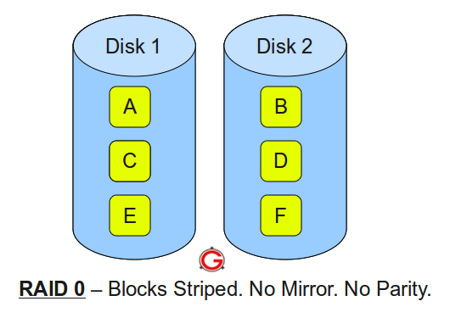

The following are the key points to remember for RAID level 0:

* Minimum 2 disks.
* Excellent performance (as blocks are striped).
* No redundancy (no mirror, no parity).
* Don’t use this for any critical system.

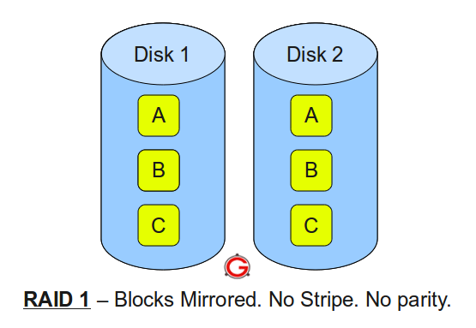

Following are the key points to remember for RAID level 1:

* Minimum 2 disks.
* Good performance (no striping. no parity).
* Excellent redundancy (as blocks are mirrored).

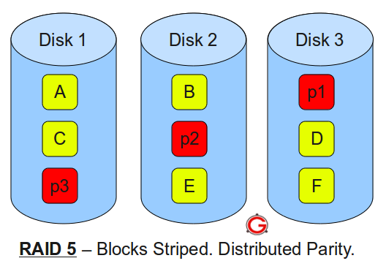

Following are the key points to remember for RAID level 5:

* Minimum 3 disks.
* Good performance (as blocks are striped).
* Good redundancy (distributed parity).
* The most cost-effective option is providing both performance and redundancy. Use this for DB that is heavily read oriented. Writing operations will be slow.

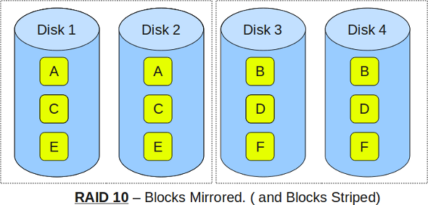

The following are the key points to remember for RAID level 10:

* Minimum 4 disks.
* This is also called as “stripe of mirrors”
* Excellent redundancy (as blocks are mirrored)
* Excellent performance (as blocks are striped)
* If you can afford the dollar, this is the BEST option for any mission critical applications (especially databases).

Network-attached storage (NAS) is a file-level (as opposed to block-level storage) computer data storage server connected to a computer network providing data access to a heterogeneous group of clients. NAS is specialized for serving files either by its hardware, software, or configuration